eCMS MANUAL

CLERANCE

Department of Revenue and Customs
Ministry of Finance

Table of Contents
1. Introduction 1
2. Logging in as Inspection Officer 1
3. Inspection 2
3.1. Document Check 2
3.1.1 Search Document Check 2
3.1.2 Create Document Check 3
3.2. Physical Inspection 3
3.2.1 Search Physical Examination 3
3.2.2 Create Physical Examination 4
3.3. Gate In Pass 4
3.3.1 Search Gate In Pass 4
3.3.2 Create Gate In Pass 5

Introduction
This document defines & illustrates the business requirements, process flows as well as the detailed functional requirements of eCMS Clearance modules to be implemented for Department of Revenue and Customs, Bhutan. Clearance modules includes below processes.
- Inspection
- Documentary check
- Physical examination
- Release
- Inter gateway movement (transit)

Customs uses the Inspection Management module to update the Documentary check and physical examination details of a cargo in the system. Inspection process is involved in all the Regime flows.

Logging in as Inspection Officer

- The user needs to log into eCMS using the url: www.ecms.gov.bt
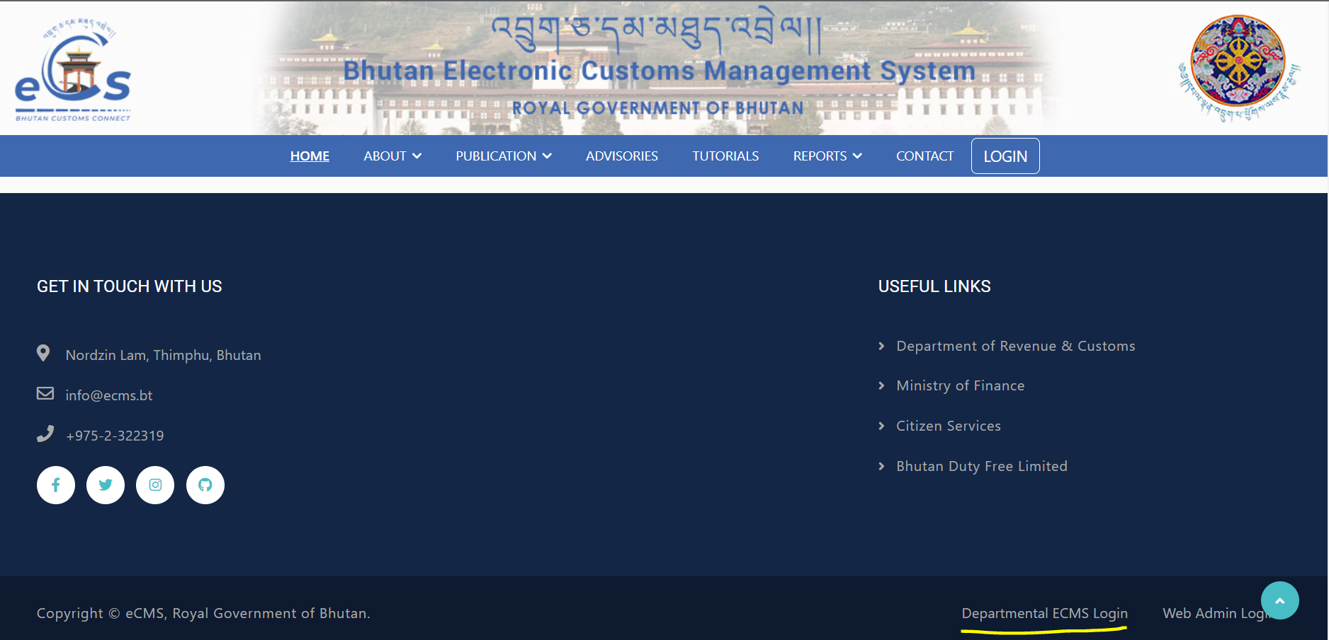
- Click on login menu and provide the required credentials to log in to the system:

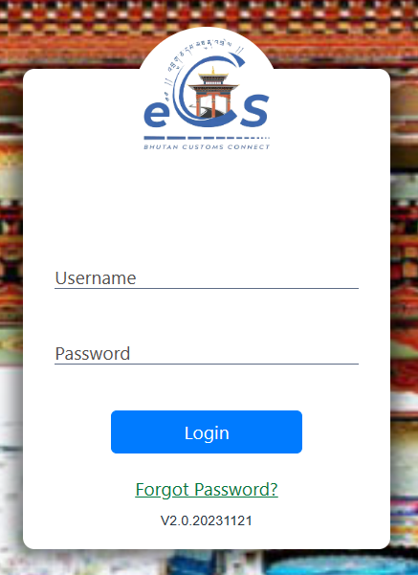

Inspection
- Click on the menu Inspection.

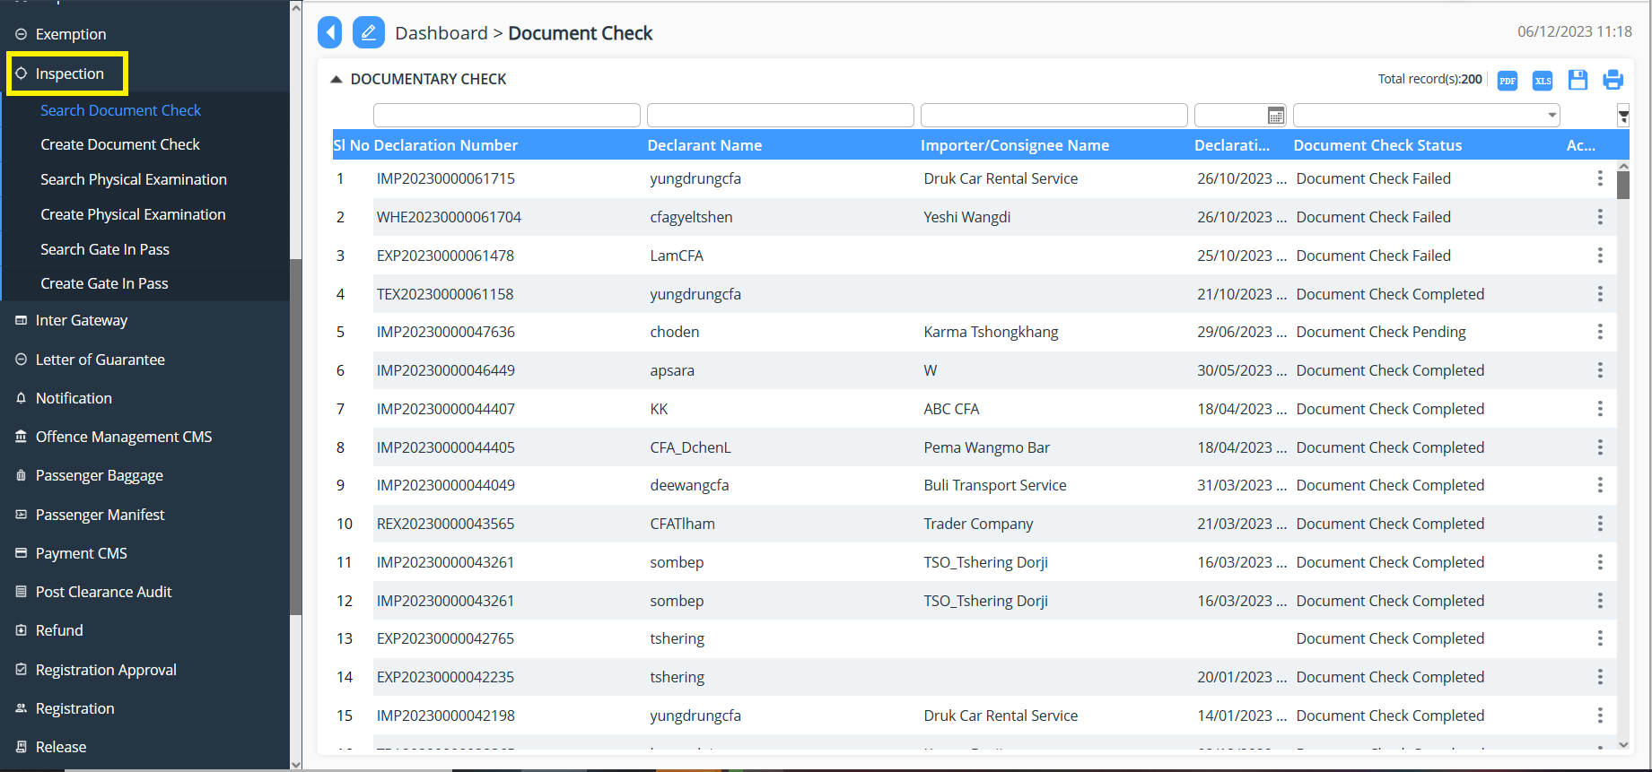

Document Check
Document check is required if the declaration assessed with yellow lane in the risk assessment module. The customs document verification officer verifies the document and update the status of verification in the system.

Search Document Check

- Click on Inspection and Select “Search Document Check”
- List of declaration that needs inspection will be listed.

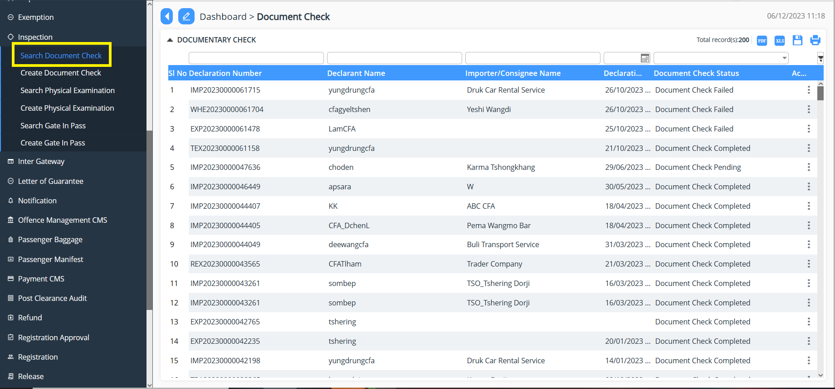

Create Document Check

- Click on Inspection
- Click on declaration that needs inspection.
- Fill in the details as per finding save the finding.
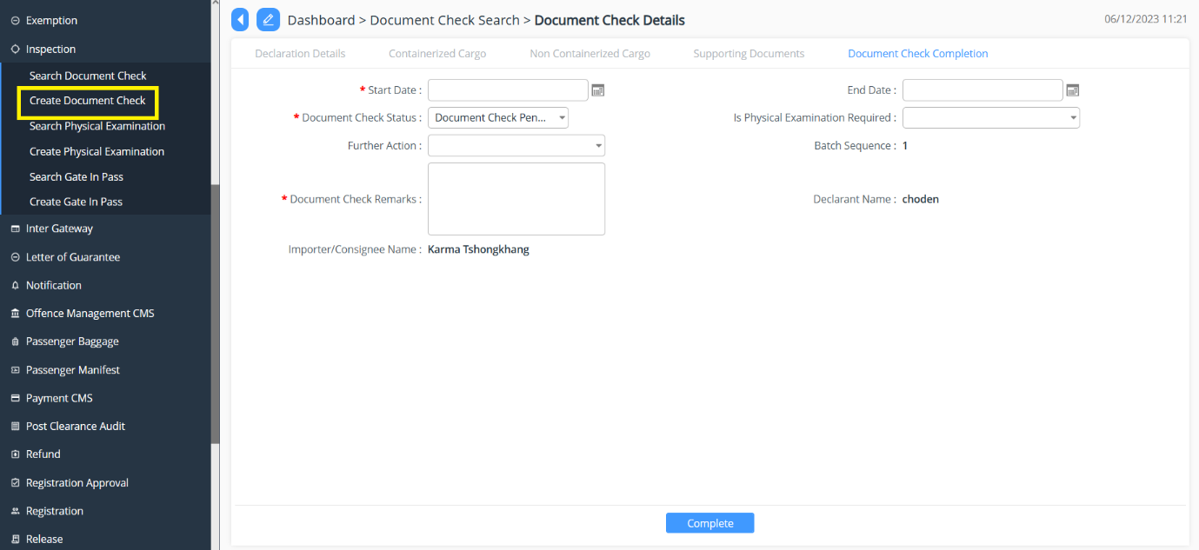

Physical Inspection

Search Physical Examination

- Click on Inspection and Select “Search Physical Examination”
- List of declaration that needs physical inspection or completed will be listed.

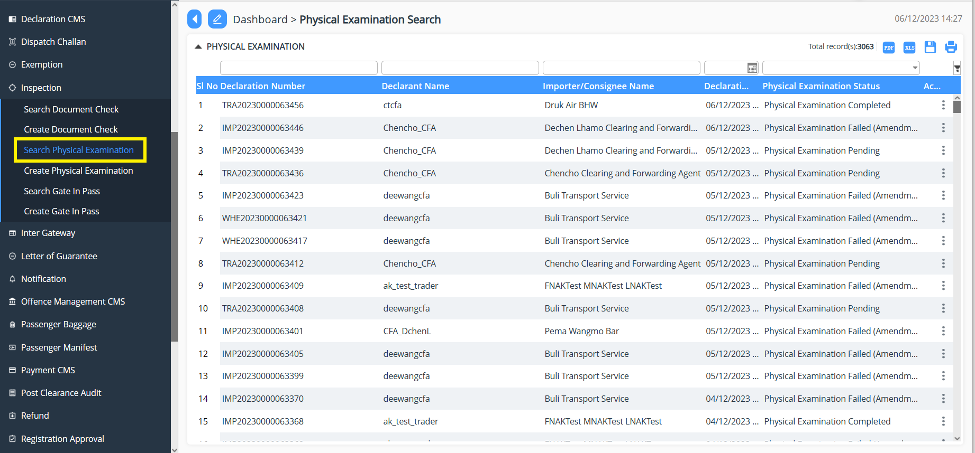

Create Physical Examination

- Click on Create Physical Examination
- Select the declaration that needs inspection.
- Fill in the details as per finding and save the finding.

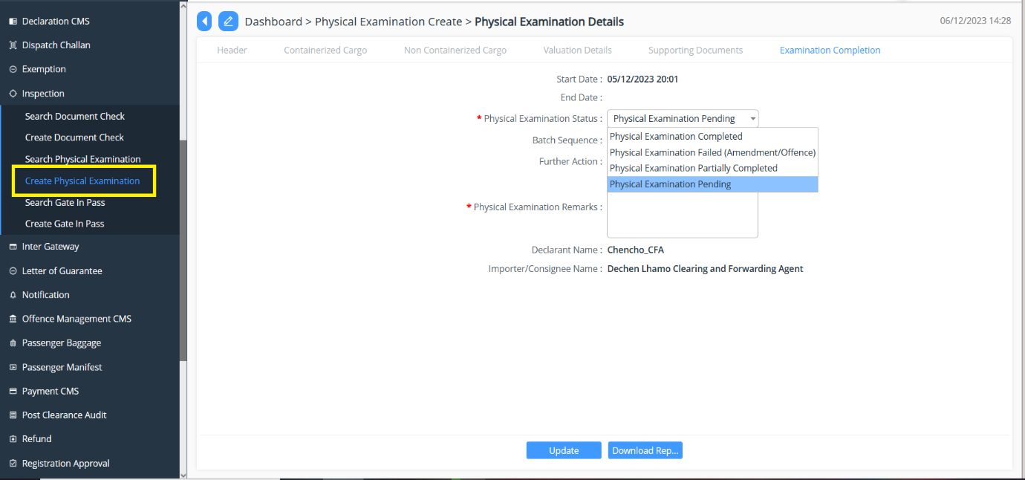

Gate In Pass

Search Gate In Pass

- Click on Inspection and Select “Search Gate in Pass”
- List of declaration that has Gate in or completed will be listed.

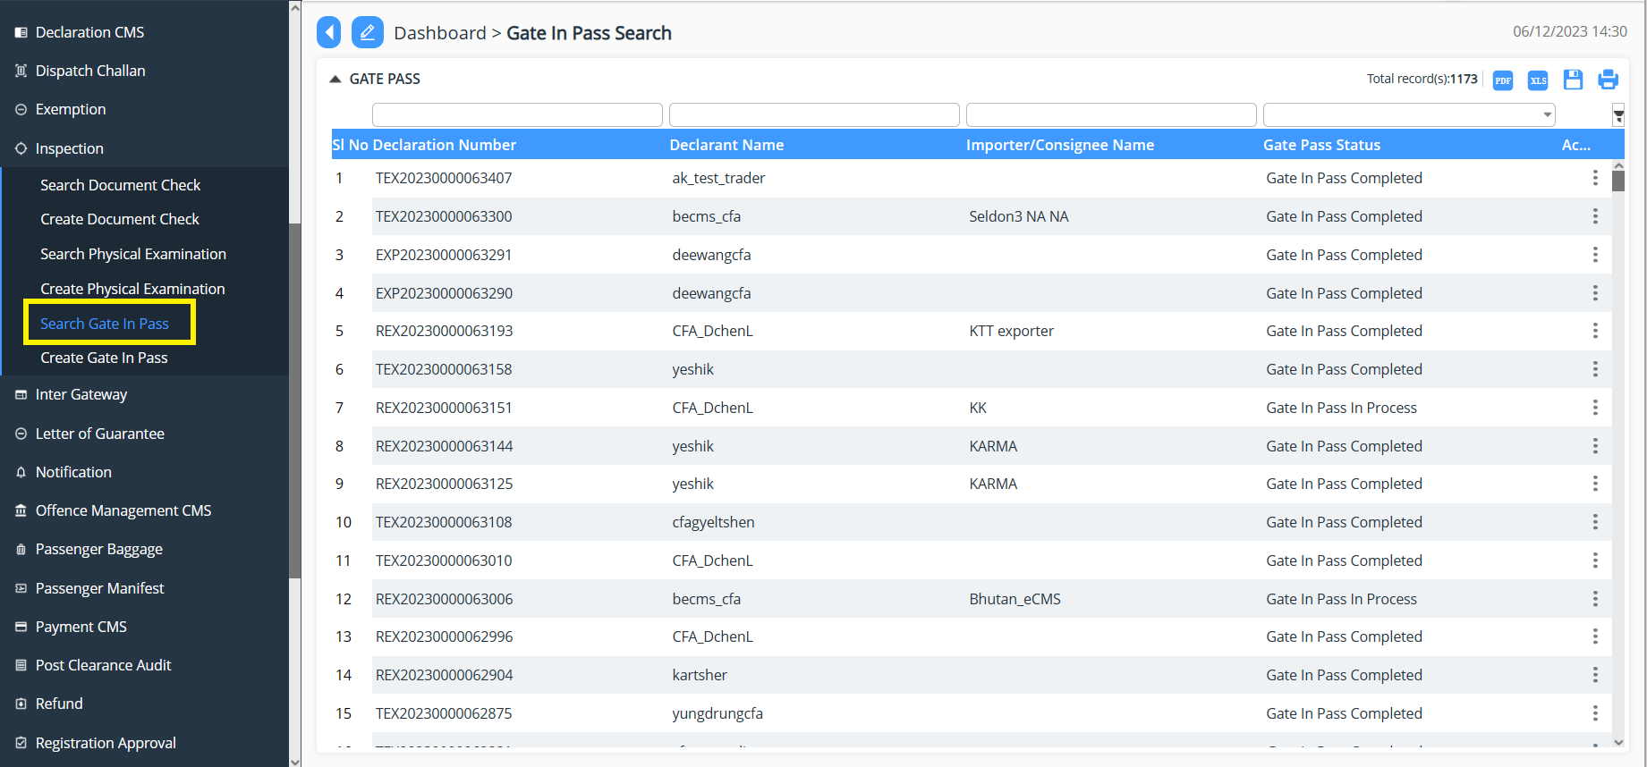

Create Gate In Pass

- Click on Create Gate in pass
- Select the declaration that needs inspection.
- Fill in the details as per finding and save the finding.

